CTF Topic: Analyzing Web Resources with Save All Resources Chrome Extension

Introduction

Save All Resources is a Chrome extension designed to help users download and save all the resources from a web page, such as HTML, CSS, JavaScript, images, and more. This can be useful for web analysis, offline browsing, and security assessments.

Scenario

As a participant in this CTF challenge, your task is to use the Save All Resources Chrome extension to download and analyze the resources of <http://testphp.vulnweb.com/>. Perform the analysis and answer the following questions based on your findings.

Begin

1. Install the Save All Resources Chrome extension from the provided link: <https://chromewebstore.google.com/detail/save-all-resources/abpdnfjocnmdomablahdcfnoggeeiedb>  
2. Visit <http://testphp.vulnweb.com/> and type ctrl+shift+I to open developer options.

3. Go to the >>> button present on the left side of the network.

4. Go on the ResourcesSaver and click on the Save All Resources.  
3. Unzip the file and capture the flag.

Questions and Answers

**Flag 1: What is the name of the file which has been downloaded?**

Answer: testphp.vulnweb.com

Flag Captured.

**Flag 2: How many CSS files are there inside the main file?**

Answer: 1

Flag Captured.

Hint

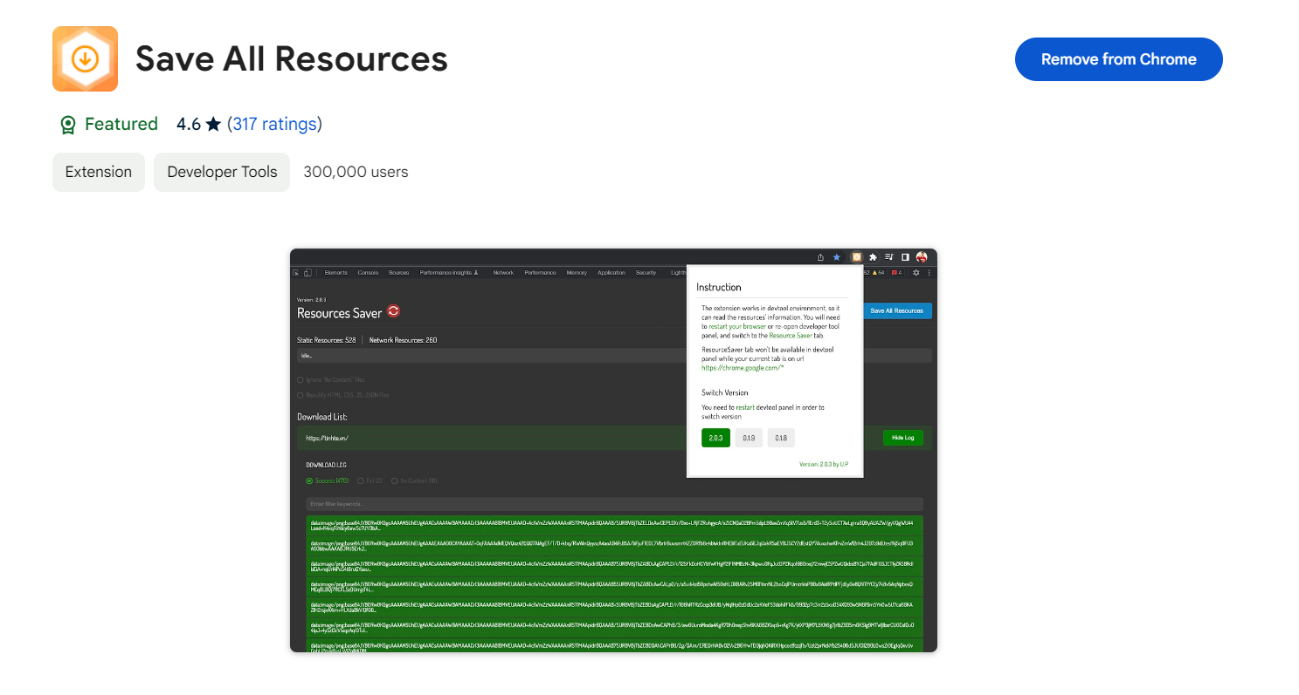

Install the Save All Resources Chrome extension and use it to download all resources from `<http://testphp.vulnweb.com/> `. Analyze the downloaded files, such as HTML, CSS, JavaScript, and images, to answer the questions accurately.To use the Save All Resources user can access it by clicking the f12 .

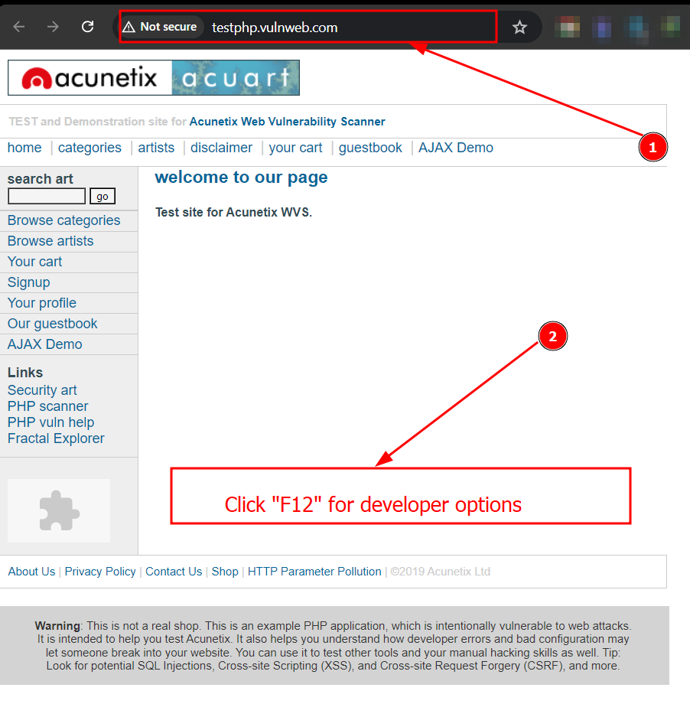

or ctrl+shift+I for developer options.

